***SQL Window Function***

***By :- Dhruv***

Question 1: Calculate the running total of sales amount. Question

SELECT

SaleID,SaleDate,CustomerID,ProductID,Amount,

SUM(Amount) OVER (ORDER BY SaleDate) AS RunningTotal

FROM Sales;

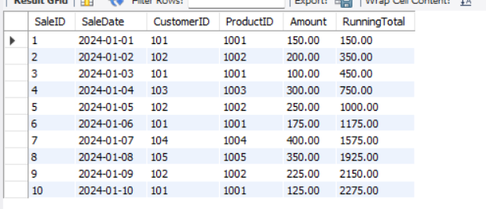

2: Calculate the average sales amount over the last 3 sales.

SELECT

SaleID, SaleDate, CustomerID, ProductID,Amount,

AVG(Amount) OVER (ORDER BY SaleDate ROWS BETWEEN 2 PRECEDING AND CURRENT ROW) AS AvgLast3Sales

FROM Sales

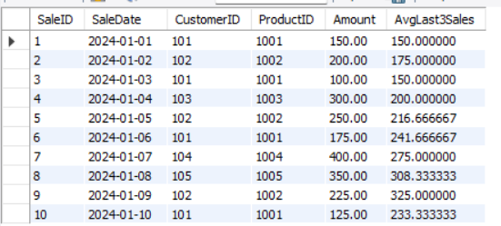

Question 3: Rank the sales by amount for each customer.

SELECT SaleID,SaleDate, CustomerID,ProductID,Amount,

RANK() OVER (PARTITION BY CustomerID ORDER BY Amount DESC) AS SalesRank

FROM Sales;

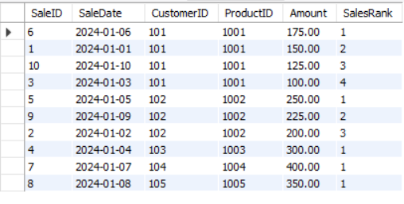

Question 4: Calculate the cumulative distribution of sales amount.

SELECT SaleID,SaleDate,CustomerID,ProductID,Amount,

CUME_DIST() OVER (ORDER BY Amount) AS CumulativeDistribution

FROM Sales;

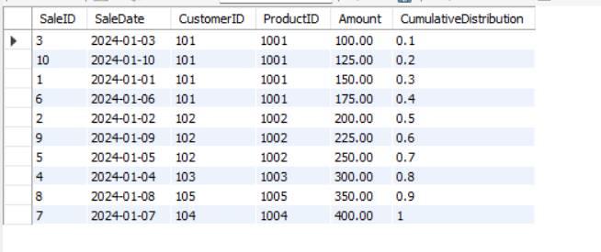

Question 5: Calculate the difference in sales amount between the current sale and the previous

sale.

SELECT SaleID,SaleDate,CustomerID,ProductID,Amount,

Amount - LAG(Amount, 1) OVER (ORDER BY SaleDate) AS AmountDifference

FROM Sales;

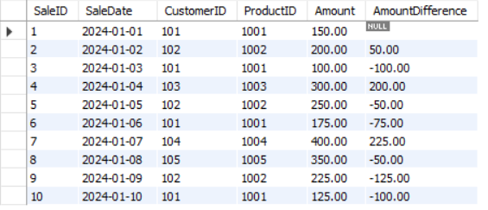

Question 6: Calculate the lead sales amount for the next sale. Question 7: Find the first sale amount for each customer.

SELECT SaleID,SaleDate,CustomerID,ProductID,Amount,

LEAD(Amount, 1) OVER (ORDER BY SaleDate) AS NextSaleAmount

FROM Sales;

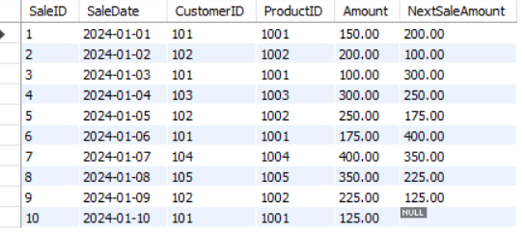

Question 7: Find the first sale amount for each customer.

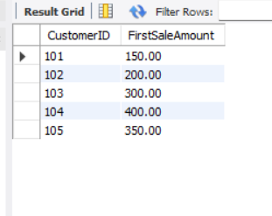

SELECT DISTINCT CustomerID,

FIRST_VALUE(Amount) OVER (PARTITION BY CustomerID ORDER BY SaleDate) AS FirstSaleAmount

FROM Sales;